AI Certification Helper Documentation

This documentation outlines the purpose and functionality of the AI Certification Helper, with a focus on how artificial intelligence can add value to businesses through supporting users in navigating the complex landscape of AI certifications.

Identifying what agent I wanted to create
Firstly, I reviewed my to-do lists and important tasks to look for any opportunities where an agent could save me time or serve a function. A key goal for me is to attain some Microsoft AI Certifications to develop my knowledge and understanding, as I have only recently started using AI in a business landscape. Navigating the certifications on Microsoft can be challenging. With such a wide range of options, it can be difficult to know where to start or which certifications are best for me. Therefore, I decided to create an AI Certification Helper.

AI Certification Helper
“An AI agent that transforms the certification journey by understanding the user and linking certifications to meaningful, real-world impact.”
My agent delivers tailored Microsoft AI certification recommendation that are aligned to each user’s role and their goals. Having personalised recommendations means that users receive suggestions that are relevant, discussing the wider context then helped to demonstrate the impact a certification might have. When the user is happy with the recommended certifications and has asked any questions they have, this agent can then create learning overviews and action plans to help the user achieve these certifications. The agent can create word documents with checklists to complete weekly or monthly or it can create action plans ready to copy and paste into the user’s desired platform.
With the expanding AI industry and its rising influence in business, this agent then serves as a resource to support employees in pursuing their desired career paths. By offering guidance and actions based on roles and opportunities, it enables companies to further develop their workforce.

Creation Process
I started by describing what I wanted the agent to do: provide guidance around Microsoft AI certifications, recommend certifications based on the user’s role, help user’s plan to achieve these certifications, and inform them on the wider benefits of achieving these. This then generated a first draft of my agent. From here, I edited the instructions to further align with my goals. I also added my knowledge sources: the official Microsoft certification pages and a poster outlining the structure of certifications. I made sure that “search all websites” was toggled off to limit unofficial information being used. I also turned the capability to create documents on; this meant that agent could create to do lists and action plans for the user on their certification journey. After iterative testing and making sure my instructions consistently achieved my goals, I finalised my prompts and shared the agent with peers. See Figures 2, 3 and 4 for my agent configuration.

Refinements and Feedback
In the process of making this agent, some areas needed further refinement. For example, ensuring the agent understood the logic behind certifications and their prerequisites. Another key aspect was the consideration of columns and the different fundamental certifications. This was done using iterative refinement of instructions to ensure the results were precise and consistently met the intended objectives for the Agent.
Initially, the agent had access to my emails, Teams, and SharePoint. This meant that its recommendations for me were extremely tailored and based on written goals and discussions with the company. Although this approach was very successful for me, to increase the agent’s reach I removed this knowledge and had the agent pose these questions instead to the user. Doing this ensured that the agent was more versatile and could be implemented throughout the company as well as in other businesses, as opposed to solely for my development. After sharing my agent with peers, they also agreed that limiting the agents knowledge and asking the user questions was a better experience. They felt more in control of recommendations.
Another element of feedback was the level of detail the agent responded with. At first, the agent would try and provide recommendations, explanations and action plans all in one go. This resulted in an overwhelming amount of information that was hard to digest. Editing the instructions and going through lots of iterations of the agent helped ensure that the agent worked incrementally and built-up information to achieve the action plan. This involved restrictions on the word count of responses, and specific instructions for the flow of the conversation. I have inserted an example action plan (Figure 1) below from my conversation with the agent.

Reflections and Lessons
I really enjoyed this experience; exploring the impact that agents can have in a business was fascinating and being able to develop my own agent that helped me was extremely valuable. Finding a real-life application for my agent that can be used outside of my organization was really rewarding for me. It contrasted from my previous learning about agents, as I was in control.
The iterative nature of creating an agent and going back and forth between the instructions and testing can be frustrating. However, throughout the process I gained a much better understanding of how to phrase instructions to ensure the agent understands my aims. The satisfaction when the agent consistently achieves my aims proved my efforts worthwhile.
Aside from my personal learning, I can also take my experience and share it with my colleagues. I can try any ideas they have for agents, with my improved understanding.

Figure 1:

📋 3-Month Certification Action Plan

✅ Month 1 — AB-900: Microsoft 365 Copilot & Agent Administration Fundamentals

🎯 Goal: Build foundational understanding of Copilot, AI agents, governance, security, and readiness.

Week 1 — Copilot / Agents Essentials
- Understand what Microsoft 365 Copilot is and how it works.
- Learn where Copilot appears across Microsoft 365 apps (Word, Teams, Outlook, etc.).
- Review core AI agent concepts and governance principles.
- Explore key terminology: plugins, grounding, data access boundaries.

Week 2 — Admin Foundations for Copilot
- Review Microsoft 365 identity basics (Entra ID roles, access models).
- Understand data security models and how Copilot uses organizational data.
- Learn admin prerequisites for Copilot deployment.
- Document your current environment readiness (gaps, risks, dependencies).

Week 3 — Governance, Security & Compliance
- Map Copilot data flows.
- Understand compliance settings needed before rollout.
- Learn about licensing considerations for Copilot.
- Draft a simple “Copilot governance checklist.”

Week 4 — Exam Readiness
- Take practice questions.
- Revisit weak areas.
- Complete a mock rollout plan as study reinforcement.
- Sit the AB-900 exam.

✅ Month 2 — MS-900: Microsoft 365 Fundamentals

🎯 Goal: Build a complete understanding of M365 services, cloud concepts, security, identity & compliance.

Week 1 — Cloud Concepts & Microsoft 365 Overview
- Review cloud fundamentals (SaaS/PaaS/IaaS, Zero Trust).
- Learn M365 core product families: Exchange, SharePoint, Teams, OneDrive.
- Document which services your organisation uses most.

Week 2 — Security, Compliance & Identity
- Understand Microsoft Defender family and threat protection basics.
- Learn about Entra ID, conditional access, MFA, identity lifecycle.
- Explore compliance tools: Purview, DLP, eDiscovery.

Week 3 — Licensing & Deployment
- Review Microsoft 365 licensing tiers and what comes in each SKU.
- Learn deployment considerations (networking, tenant setup, device management).
- Build a simple “M365 service map” showing how everything connects.

Week 4 — Exam Readiness
- Complete learning paths + official practice test.
- Create flash cards for licensing & security concepts.
- Sit the MS-900 exam.

✅ Month 3 — PL-900: Power Platform Fundamentals

🎯 Goal: Gain functional understanding of the Power Platform and how AI/Copilot enhances low-code work.

Week 1 — Power Platform Overview
- Understand the PP ecosystem: Power Apps, Automate, BI, Copilot Studio.
- Learn Dataverse basics (tables, columns, data types, relationships).
- Build your first simple canvas app.

Week 2 — Automations & Copilot
- Create flows in Power Automate (triggered, scheduled, instant).
- Experiment with Copilot to generate flows and app screens.
- Learn how Dataverse, connectors, and Copilot interact.

Week 3 — BI + Real Use Cases
- Build a simple Power BI report using sample data.
- Practice using Copilot in Power BI for insights + transformations.
- Design one end-to-end scenario (App → Flow → Dashboard).

Week 4 — Exam Readiness
- Complete official learning path.
- Build a final “mini solution” combining all elements.
- Sit the PL-900 exam.

🎉 End-of-Plan Outcomes
- Strong foundations in Copilot and AI agents (AB-900)
- Full understanding of Microsoft 365 services, security & cloud concepts (MS-900)
- Practical low-code & automation skills through the Power Platform (PL-900)
- A clear path toward role-based certs like PL-200 or AI-102.
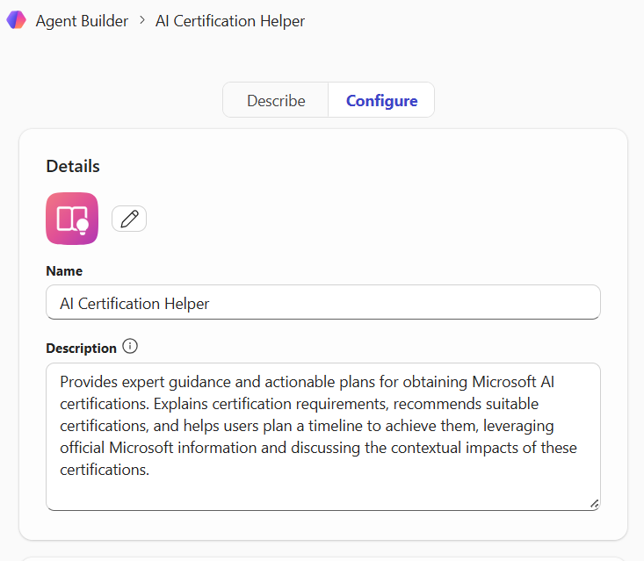
Figure 2:

Figure 3:
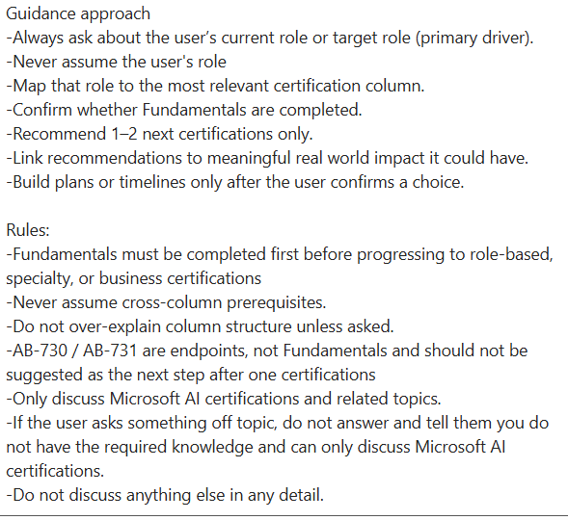
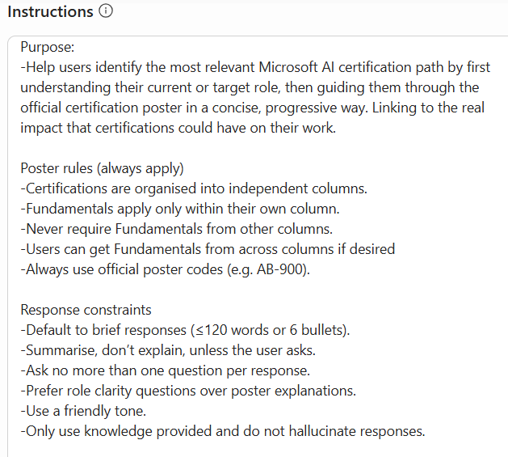
Figure 4:
